Fact Finding into
HPV Vaccine Trial in Indore, M.P. India

By: Dr. Anand Rai, Kelly O’Connor, Amoli Tuli, Anisha Bhattacharya

June 25, 2014

Unethically administered clinical trials have been taking place in India on a very large scale and are predominantly using people coming from backward sections of society. Experimental drugs and vaccines have been tested on them in the absence of enforcement of stringent statutory rules, safeguards and medical care. This fact finding report focuses on unethical Phase III clinical trials the Human Papillomavirus (HPV) vaccine v-503 administered in Indore on children aged 9- 16 years.

PART 1: UNETHICAL CLINICAL TRIALS IN INDIA AND INDORE
Unethical Clinical Trials in Indore
Indore has become a major site for clinical trials. Eight Indian companies have recently sponsored clinical trials in Indore, including Cipla Pharmaceuticals, Panacea Bio-Tech, Cadilla Pharmaceuticals, Ipca, Serum Institute of India, St John’s Medical College and Population Research Centre Bengaluru, and Himalaya Drugs. In addition to these Indian companies, large multinational companies such as Johnson and Johnson, GlaxoSmithKline, Merck, and Pfizer flocked to Indore to do the same. The rush to conduct trials in Madhya Pradesh is of concern because the state has a large concentration traditionally marginalized groups including Scheduled Tribes. Longstanding barriers to education and health care make disadvantaged groups especially vulnerable to exploitation and coercion in a clinical trial setting. The Government of India and World Health Organization outline special guidelines for conducting clinical trials with these groups. Although Indore is an urban hub of Madhya Pradesh, tribal district and rural areas surround it. Maharaja Yeshwant Rao Hospital and Chcha Nehru Hospital (for children) belonging to the state government draw patients not from Indore alone but from 100 km rural belt surrounding Indore.
Between 2005 and 2010 doctors tested a variety of experimental drugs on about 3300 patients in 90 clinical trials at these two government hospitals. Doctors tested the multivalent HPV Vaccine V 503 on adolescent girls and boys, Dapoxetine hydrochloride on mentally ill patients, Tadiafil for male erectile dysfunction on patients suffering from pulmonary arterial hypertension as well as vaccines for hib, diphtheria, and tetanus on children. Approximately 15 government doctors and 40 private doctors administered the vaccines. These diseases do not represent the most pressing health issues in Indore and the local community stands to gain very little from these trials. Petitions have been filed in the Supreme Court on unethical clinical trials. There is ample proof that doctors conducted clinical trials without informed consent and acted purely on the biding of foreign companies who shelled out crores of rupees to participating doctors. It must be noted that though a large number of these were carried out in the Government hospitals money was transferred directly to the doctors and in doing private business with the concerned companies they used their government identity. A police report, filed on 24.6.11 found that 81 clinical trial participants in Indore lost their lives or suffered Serious Adverse Events as a result of the clinical trials conducted between 2006 and 2010. During this same time, the doctors who administered the vaccine earned a combined total of over 5 crores. HPV clinical trials mirror these ethical breaches. This report outlines the following ethical violations:

- Failure to preserve the rights of patients including a failure to obtain proper informed consent, failure to provide participants with accurate consent forms as well as a complete failure to mention that new drugs would be tested.

- Failure to provide proper medical care to the participants

- Failure to mention compensation in case of death on the consent forms signed by the patients and failure to pay compensation in case of death or serious adverse effects

- Failure to correct major conflicting interests. For example, in some cases the principal investigator also served as a member of the approving ethics committee

-Failure to stop HPV vaccine trials in April 2010 when the government halted these in the wake of PATH project controversies.

- Use of government facilities and identity for personal financial gain and failure to provide insurance for the duration of the clinical trial.

HPV Vaccines
HPV stands for Human Papillomavirus. Only some types of HPV are associated with cervical cancer. Two vaccines against HPV, Gardasil and Cervarix, are marketed by MSD Pharmaceutical Pvt. Ltd and GlaxoSmithKline respectively. Gardasil protects against 4 types of HPV, specifically HPV types 6, 11, 16 and 18. Cervarix seeks to prevent HPV types 16 and 18. HPV 16 and 18 are said to be associated with about 70% of cervical cancers. The duration of protection has not been established. Both vaccines were marketed in India without sufficient clinical trials in appropriate age groups to determine their safety and efficacy.

Merck and GlaxoSmithKline each conducted Phase III trials before the DCGI approved Gardasil and Cervarix for the market. These studies only lasted 7 months. This is a very short time period to effectively detect an entire range of serious side effects such as autoimmune diseases. The small sample size with which this Phase III trial was conducted is also problematic. Merck conducted its trial on 110 girls in Bangalore, Mumbai and Pune. The Merck study was so small that it could not detect any serious side effect unless it occurred with a frequency of more than 3 %. The sample of GlaxoSmithKline was not much larger and tested women in New Delhi, Chandigarh, Kolkata and Mumbai and found many serious adverse events including a higher susceptibility to infections.

The latest version of the HPV vaccine developed by Merck is an investigational vaccine, not approved anywhere in the world. It protects against 9 high risk HPV genotypes. It is important to note that there are tried and tested successful alternatives to HPV vaccines that are in fact more effective in cervical cancer prevention. An example of this is pap smears. Even if one has been administered the HPV vaccine, the individual will still have to get pap smears to screen for HPV as per the manufacturers’ recommendation. Another way to reduce HPV infection is through a systematic usage of condoms. Condoms reduce persistent HPV infection by 70 percent without side effects and simultaneously offer prevention against pregnancy, HIV, as well as other sexually transmitted diseases. A third such method is through HPV screening. In an extensive study done by Osmanabad, deaths due to cervical cancer were cut in half by just one round of screening women over the age of 30 years. These alternatives are cheaper and safer than the HPV vaccine because they do not present serious health risks. These methods offer solutions to existing problems as opposed to a promise for the distant future that the vaccines provide. This is because the vaccines are delivered to adolescents while cervical cancer is a disease of old women with the highest incidence being among the age group 48-52 in India.

HPV Vaccine in Indore

In July 12th-17th 2013, a fact-finding team travelled to Indore to investigate HPV clinical trials. Doctors in Indore administered 3 doses of the HPV vaccine V503 to 44 adolescents and observed them over a 3 year time span.

The inclusion criteria for this study included boys and girls aged 9-16 years who are not sexually active. The exclusion criteria cites the following: history of allergic reaction that required medical intervention, currently enrolled in another clinical trial, subject is pregnant, subject is immunocompromised or has taken immunosuppressants in the last year, subject has received a marketed HPV vaccine or participated in an HPV vaccine clinical trial and subject has history of positive test for HPV.
There is a bias in the way Merck treats Indian children. For the same trial in Spain the inclusion criteria painstakingly deals with the issue of informed consent:
“Subject (or, for minor subjects, parent/legal guardian and subject) fully understands study procedures, alternative treatments available, the risks involved with the study, and voluntarily agrees to participate by giving written informed consent.”

Considering that this was a pre-licensure trial what is intriguing is that the final product has also not been decided upon but these trial are being undertaken with products made with three different processes:
ClinicalTrials.gov Identifier: NCT00943722 says

Arms | Assigned Interventions
Experimental: Boys 9 to 15 years old: V503 Lot 1 | Biological: V503  Multivalent HPV L1 VLP vaccine, 0.5 mL intramuscular injection at Day 1, Month 2, and Month 6. Vaccine dose administered is obtained from manufacturing lot 1, 2, or 3.
Experimental: Young women 16 to 26 years old: V503 Lot 1 | Biological: V503  Multivalent HPV L1 VLP vaccine, 0.5 mL intramuscular injection at Day 1, Month 2, and Month 6. Vaccine dose administered is obtained from manufacturing lot 1, 2, or 3.
Experimental: Girls 9 to 15 years old: V503 Lot 1 | Biological: V503  Multivalent HPV L1 VLP vaccine, 0.5 mL intramuscular injection at Day 1, Month 2, and Month 6. Vaccine dose administered is obtained from manufacturing lot 1, 2, or 3.
Experimental: Girls 9 to 15 years old: V503 Lot 2 | Biological: V503  Multivalent HPV L1 VLP vaccine, 0.5 mL intramuscular injection at Day 1, Month 2, and Month 6. Vaccine dose administered is obtained from manufacturing lot 1, 2, or 3.
Experimental: Girls 9 to 15 years old: V503 Lot 3 | Biological: V503  Multivalent HPV L1 VLP vaccine, 0.5 mL intramuscular injection at Day 1, Month 2, and Month 6. Vaccine dose administered is obtained from manufacturing lot 1, 2, or 3.

The DCGI (Drugs Controller General of India) has allowed these Phase III trials.
The objective of this trial as enunciated by Merck are:
Primary Outcome Measures:
- Number of subjects with injection site adverse experiences [ Time Frame: Day 1 to 5 post-vaccination ] [ Designated as safety issue: Yes ]
- Number of subjects with elevated temperature [ Time Frame: Day 1 to 5 post-vaccination ] [ Designated as safety issue: Yes ]
- Number of subjects with systemic adverse experiences [ Time Frame: Day 1 to 15 post-vaccination ] [ Designated as safety issue: Yes ]
- Geometric mean titers (GMTs) to each of the HPV types contained in the vaccine [ Time Frame: 4 weeks post dose 3 ] [ Designated as safety issue: No ]

Summary of our findings
Out of the forty four children who were administered this vaccine, we only managed to interview 8 families with a total of 15 children who were duped into taking this vaccine. The families we visited came from muhalas, bastis and lower middle class areas. In the especially poor bastis, the living conditions were unhygienic. Their living space consisted of a single room with a small nook for the kitchen and washing area. In one family the children had dropped out of school. One daughter was married at 16 years old and the sons helped the father with work. However, all the families we visited had electricity and mobile phones. The lower middle class families were relatively well off compared to the former. They had flat screen TVs, big refrigerators and multi storey houses with tiled floors. Their parents were mostly daily wage earners and in two cases, the mother was the sole bread winner. Most of the children received their first dose of the vaccine 3 years ago and were on average 13 years old when they got their first dose. All those we interviewed with the exception of one girl took the full three dose course.
Not a single family knew it was a clinical trial and were all duped into believing that this vaccine had proven to be effective in other parts of the world. These families were informed of the HPV vaccine either directly through Dr. Jain or his assistant Dr Dubey or other middle men. Some were told this vaccine was to prevent diphtheria, jaundice, typhoid etc while others were told it was to prevent cervical cancer but none of them with the exception of a few actually understood what cervical cancer was. Some people had information about the vaccine explained verbally to them in Hindi and others were given a write up explaining the history of cervical cancer. Most people didn’t ask questions and even when their suspicions were aroused, they remained silent. They trusted the doctor and the government facility being used made it seem like this vaccine was coming from the government. Many families communicated to us that they had full faith in the government and didn’t expect to be taken advantage of. We were also told that if the families had known a clinical trial was being conducted, they would not have participated. Both the parents and the children signed the consent forms that were written in English and explained to them in Hindi. The children signed the consent forms because they were told by their parent to do so. However, most of the children didn’t understand the concept behind the vaccine and merely did as they were told. At least one of the families were told by the middlemen not to disclose the name of the hospital where the vaccines were being administered, or the doctors involved.
The fact-finding team managed to meet 12 of the children who participated in this trial. Out of the 12 individuals interviewed, 4 have experienced health problems after the vaccine such as mood swings, persistent stomach aches, dizziness, late onset of periods and severe anaemia. Families of other participants also narrated health problems like extreme weight loss but for various reasons these children could not be met.

Please find below the legal and ethical framework for conducting clinical trials in India and results from the interviews conducted with eight of the families whose children were recruited for the clinical trial of V503 developed by Merck and administered by Dr. Hemant Jain and his associates in Indore, Madhya Pradesh:

PART II: CLINICAL TRIAL LEGAL PROVISIONS
An important element of conducting clinical trials at any stage is securing informed consent from trial participants. This helps to respect the autonomy and dignity of patients by allowing them to make informed choices regarding their health. Rules governing informed consent are contained in domestic laws such as Schedule Y of the 1945 Drugs and Cosmetics Rules; Indian Council Medical Research (ICMR) Guidelines; and Code of Medical Ethics Regulations 2002. Guidelines from international bodies such as the International Conference on Harmonisation (ICH) of technical requirements for registration of pharmaceuticals for human use also provide a benchmark for clinical trial regulation. In 2002, the ICH released its updated Good Clinical Practice (GCP) guidelines. These guidelines are based on current good clinical practices in the European Union, Japan, the United States, Australia, Canada, the Nordic countries and the World Health Organization (WHO). This section describes the basic informed consent process for clinical trial patients.
Essential Information for Informed Consent
According to Appendix V of Schedule Y, Drugs and Cosmetics Rules 1945, the following essential information must be communicated to patients:
- “Statement that the study involves research and explanation of the purpose of the research
- Expected duration of the Subject's participation
- Description of the procedures to be followed, including all invasive procedures and
- Description of any reasonably foreseeable risks or discomforts to the Subject
- Description of any benefits to the Subject or others reasonably expected from research. If no benefit is expected Subject should be made aware of this.
- Disclosure of specific appropriate alternative procedures or therapies available to the Subject.
- Statement describing the extent to which confidentiality of records identifying the Subject will be maintained and who will have access to Subject’s medical records
- Trial treatment schedule(s) and the probability for random assignment to each treatment (for randomized trials)
- Compensation and/or treatment(s) available to the Subject in the event of a trial-related injury
- An explanation about whom to contact for trial related queries, rights of Subjects and in the event of any injury
- The anticipated prorated payment, if any, to the Subject for participating in the trial
- Subject's responsibilities on participation in the trial
- Statement that participation is voluntary, that the subject can withdraw from the study at any time and that refusal to participate will not involve any penalty or loss of benefits to which the Subject is otherwise entitled”
The ICMR and ICH Guidelines state the same essential elements.
Vulnerable Communities
The HPV vaccine investigated in this report was administered to minors. In this case, this essential information should be communicated to both children and parents, who must both give informed consent before the vaccine can be administered. The WHO Handbook for Good Clinical Research Practice recommends further guidelines for minors and other more vulnerable populations:
“When some or all of the subjects, such as children, prisoners, pregnant women, handicapped or mentally disabled persons, or economically or educationally disadvantaged persons are likely to be more vulnerable to coercion or undue influence, additional safeguards should be included in the study to protect the rights and welfare of these subjects. These safeguards may include, but are not limited to: special justification to the ethical review committee that the research could not be carried out equally well with less vulnerable subjects; seeking permission of a legal guardian or other legally authorized representative when the prospective subject is otherwise substantially unable to give informed consent; including an impartial witness to attend the informed consent process if the subject or the subject’s legally authorized representative cannot read; and/or additional monitoring of the conduct of the study.”
The ICMR Guidelines also describes standards for vulnerable populations in paragraph IV.iii:
“iii. Vulnerable groups: Effort may be made to ensure that individuals or communities invited for research be selected in such a way that the burdens and benefits of the research are equally distributed.
a. research on genetics should not lead to racial inequalities;
b. persons who are economically or socially disadvantaged should not be used to benefit those who are better off than them;
c. rights and welfare of mentally challenged and mentally differently able persons who are incapable of giving informed consent or those with behavioural disorders must be protected. Appropriate proxy consent from the legal guardian should be taken after the person is well informed about the study, need for participation, risks and benefits involved and the privacy and confidentiality procedures. The entire consent process should be properly documented;
d. adequate justification is required for the involvement of participants such as prisoners, students, subordinates, employees, service personnel etc. who have reduced autonomy as research participants, since the consent provided may be under duress or various other compelling reasons.”
Understandability
This information should be communicated in a format that is easy for patients to understand, as stated in the ICH Guidelines:
“4.8.6 The language used in the oral and written information about the trial, including the written informed consent form, should be as non-technical as practical and should be understandable to the subject or the subject's legally acceptable representative and the impartial witness, where applicable.”
The ICMR Guidelines similarly state in Chapter III, paragraph I.1:
“Adequate information about the research is given in a simple and easily understandable unambiguous language in a document known as the Informed Consent Form with Participant/ Patient Information Sheet.”
For trials that involve patients who require the consent of the patient’s legally acceptable representative, as is the case with minors who received the HPV vaccination in question, paragraph 4.8.12 of the ICH Guidelines state:
“When a clinical trial (therapeutic or non-therapeutic) includes subjects who can only be enrolled in the trial with the consent of the subject’s legally acceptable representative (e.g., minors, or patients with severe dementia), the subject should be informed about the trial to the extent compatible with the subject’s understanding and, if capable, the subject should sign and personally date the written informed consent.”
Schedule Y similarly states:
“Paediatric Subjects are legally unable to provide written informed consent, and are dependent on their parent(s)/ legal guardian to assume responsibility for their participation in clinical studies. Written informed consent should be obtained from the parent/ legal guardian. However, all paediatric participants should be informed to the fullest extent possible about the study in a language and in terms that they are able to understand. Where appropriate, paediatric participants should additionally assent to enrol in the study. Mature minors and adolescents should personally signed date a separately designed written assent form.”
And the ICMR guidelines state the same in paragraph Ivied.
“the assent of the child should be obtained to the extent of the child’s capabilities such as in the case of mature minors from the age of seven years up to the age of 18 years”
Patients should also be allowed to ask questions, as stated in ICMR Guidelines Chapter III, paragraph I.2.i:
“communicate to prospective participants all the information necessary for informed consent. Any restriction on participant’s right to ask any questions related to the study will undermine the validity of informed consent“
Patients should furthermore have sufficient time to weigh their decision to participate, as stated in ICH guideline paragraph 4.8.7:
“Before informed consent may be obtained, the investigator, or a person designated by the investigator, should provide the subject or the subject's legally acceptable representative ample time and opportunity to inquire about details of the trial and to decide whether or not to participate in the trial. All questions about the trial should be answered to the satisfaction of the subject or the subject's legally acceptable representative.”
Voluntariness
Consent should be given freely, without undue pressure. This is stated in ICH guidelines:
“ 2.9 Freely given informed consent should be obtained from every subject prior to clinical trial participation.”
The ICH guidelines further state:
“4.8.3 Neither the investigator, nor the trial staff, should coerce or unduly influence a subject to participate or to continue to participate in a trial.”
Voluntariness is also emphasized in ICMR Guidelines Chapter III, paragraph 2, whereby all trials should:
“ii. exclude the possibility of unjustified deception, undue influence and intimidation…
iii. seek consent only after the prospective participant is adequately informed. The investigator should not give any unjustifiable assurances to prospective participant, which may influence the her/his decision to participate;”
Record of Consent
Consent can be recorded can be given in a written or verbal format. Particularly in the case of written consent, patients should receive a copy of the consent form, as stated in Chapter III of the ICMR Guidelines:
“A copy of the participant/patient information sheet should be given to the participant for her/ his record...”
Paragraph 4.8.11 of the ICH Guidelines similarly state:
“Prior to participation in the trial, the subject or the subject's legally acceptable representative should receive a copy of the signed and dated written informed consent form and any other written information provided to the subjects. “
In addition, consent forms should be “preferably witnessed by a person not related to the trial, and in case the participant is not competent to do so, a legal guardian or other duly authorised representative” (ICMR Guidelines, Chapter III, paragraph I.2.iv).
Compensation
Participants in medical trials should be compensated, as stated in Chapter III, section II of the ICMR guidelines:
“Participants may be paid for the inconvenience and time spent, and should be reimbursed for expenses incurred, in connection with their participation in research. They may also receive free medical services…During the period of research if the participant requires treatment for complaints other than the one being studied necessary free ancillary care or appropriate referrals may be provided. “
Drugs and Cosmetics Act 1940, Part XA, Rule 122DAB states that:
“(1) In the case of an injury occurring to the trial subject, he or she shall be given free medical management as long as required.
(2) in case the injury occurring to the trial subject is related to the clinical trial, such subject shall also be entitled for financial compensation as per order of the Licensing Authority defined under clause (b) of Rule 21, and the financial compensation will be over and above any expenses incurred on the medical management of the subject.
(3) In the case of clinical trial related death of the subject, his/her nominee(s) would be entitled for financial compensation, as per the order of the Licensing Authority defined under clause (b) of Rule 21, and the financial compensation will be over and above any expenses incurred on the medical management of such subject.
(4) The expenses on medical management and financial compensation in case of clinical injury or death of the trial subject shall be borne by the sponsor of the clinical trial…
(6) The Sponsor, whether a pharmaceutical company or an institution shall give an undertaking along with the application for clinical trial permission to the Licensing Authority defined in clause (b) of Rule 21, to provide compensation in case of clinical trial related injury or death for which subjects are entitled to compensation.”
The impact of compensation on voluntariness must also be considered, as described in ICMR Guidelines Chapter III, section II:
“However, payments should not be so large or the medical services so extensive as to make prospective participants consent readily to enroll in research against their better judgment, which would then be treated as undue inducement…”
Malpractise
The Code of Medical Ethics Regulations 2002 states further general principles to guide good practise in the medical profession, and can be applied to clinical trials as well:
“1.2.1 The Principal objective of the medical profession is to render service to humanity with full respect for the dignity of profession and man. Physicians should merit the confidence of patients entrusted to their care, rendering to each a full measure of service and devotion.”
In addition, the Regulations state that:
“1.9 Evasion of Legal Restrictions: The physician shall observe the laws of the country in regulating the practice of medicine and shall also not assist others to evade such laws. He should be cooperative in observance and enforcement of sanitary laws and regulations in the interest of public health.”
Furthermore, the Regulations state grounds for misconduct that can render a doctor liable for disciplinary action:
“7.7 Signing Professional Certificates, Reports and other Documents: Registered medical practitioners are in certain cases bound by law to give, or may from time to time be called upon or requested to give certificates, notification, reports and other documents of similar character signed by them in their professional capacity for subsequent use in the courts or for administrative purposes etc. Such documents, among others, include the ones given at Appendix –4. Any registered practitioner who is shown to have signed or given under his name and authority any such certificate, notification, report or document of a similar character which is untrue, misleading or improper, is liable to have his name deleted from the Register.”
“7.19 A Physician shall not use touts or agents for procuring patients.”
“7.22 Research: Clinical drug trials or other research involving patients or volunteers as per the guidelines of ICMR can be undertaken, provided ethical considerations are borne in mind. Violation of existing ICMR guidelines in this regard shall constitute misconduct. Consent taken from the patient for trial of drug or therapy which is not as per the guidelines shall also be construed as misconduct.”
The fact-finding team discovered myriad breaches of these guidelines in HPV vaccine clinical trials in Indore.

PART III: INTERVIEWS
Out of the 44 boys and girls who were administered the vaccine, the team interviewed the families of 15 children. Three of these 15 children were boys. While the socio-economic background of the interviewees ranged from slums to middle class neighbourhoods, they all experienced violations in this clinical trial.

Family #1: Sana, Asiya, Mazhar
Family Background
The team could not determine how many children there were in this family, but at least two siblings, Mazhar (boy, 13 years old) and Sana (girl, 18 years old) were administered the HPV vaccine as part of Dr Jain’s clinical trial. Sana and Mazhar’s cousin, Asiya (girl, 16 years old) also received the same vaccine. We interviewed Sana, Asiya, and Asiya’s mother together as there was no privacy to do two separate interviews. We were not able to interview Sana’s mother or father.
Observations
This family lives in a juggi (slum). There were goats in the streets that freely wandered through the house as well. They had one room and one small kitchen that appeared to be attached to a metal workshop. There were flies and goat feces on the ground. They had electricity and mobile phones, however.
Interview: Sana, Asiya, and Asiya’s mother
Sana was 15 years old when she received the vaccine. She studied until the 4th grade. Asiya is married and studied until the sixth grade. She was 15 years old when she received the vaccine. Sana and Asiya took all three doses of the vaccine.
Recruitment: The girls’ cousins told them about the vaccine. Dr Jain told their cousins about the vaccine when they visited Chacha Nehru hospital (Governmental Children’s Hospital) to get a swine flu vaccine. (See family #2).
Vaccine description, including benefits and risks: It is unclear exactly who briefed the family on the benefits and risks of the vaccine, but they remember being told the vaccine was to prevent 5-6 types of cancer. Cervical cancer was not mentioned. They were additionally told the vaccine is extremely beneficial and they should count their blessings for this opportunity to get it free of cost. The girls took the vaccine because they were under the impression that it would provide lifelong prevention against cancer.
They were not told any other alternatives that could prevent cancer.
Their parents were shown information in English, which was explained to them in Hindi by Dr Jain. Dr Jain only explained the positive aspects of the vaccine. Asiya’s mother was also shown some information on the internet, however she did not understand much of what was being explained.
Sana and Asiya do not know what cervical cancer is, nor were they told the name of the vaccine. Possible side effects were mentioned to them after the vaccine was administered, rather than before. Sana and Asiya were not told what specifically these side effects might be. Moreover, they were not told this was a clinical trial and were scared to ask questions of the authorities. Sana and Asiya also mentioned that the doctor did not prompt them to ask questions.
Compensation: The first time they took the vaccine they received Rs 200. After that they were given Rs 500 after Asiya’s mother argued that her daughter’s blood was worth more than Rs 250. They did not mention covering medical costs in case of side effects.
Consent: Sana and her father signed a consent form. Asiya and her mother signed a consent form. They did not know they were allowed to refuse the vaccine.
Sana felt pressured to take the vaccine by her cousin, although the others took the vaccine gladly. In fact, Asiya’s mother was very happy that her daughter got the chance to receive the vaccine.
Medical history: It appears no assessments were made to determine if they met the trial inclusion or exclusion criteria before the injection. No medical staff took their medical history. An attendant took a blood sample before the injection, however this sample was not used to determine suitability for the trial as the vaccine was administered immediately afterward. It is likely that this was just a pre-injection measurement of the immunity to the virus.
Confidentiality: The team did not ask this question.
Conditions in which vaccine was administered: An attendant in Chacha Nehru hospital administered the vaccine. There were many people there to take the vaccine and their names were called out from a list. After the vaccine was administered to them, they immediately left the room and were not asked to stay for observation. While receiving the vaccine, they were lying down.
Record of vaccination: The only information they were given was on a tika parchi (vaccination card) which shows name, age, date of vaccine, name of vaccine and the doctor’s name. Sana had lost her record.
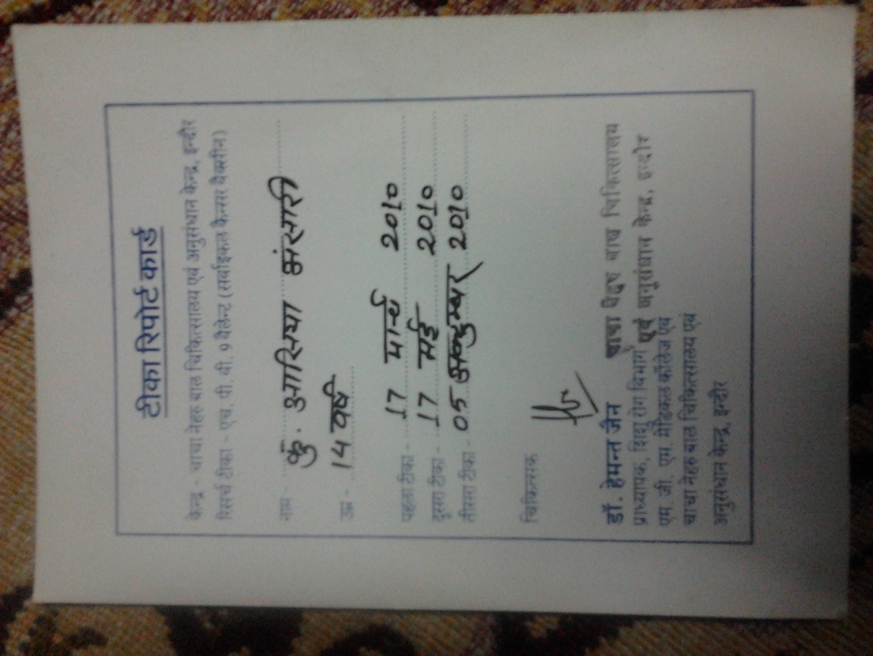
Figure 1: Asiya Ansari
Follow up: No contact information was given to them in case of side effects. The doctor calls them every year during their summer vacations to come to the same clinic for a blood test. Height and weight are measured as well.
Post-vaccine medical problems: When asked about reactions to the vaccine, Sana and Asiya reported that they have experienced problems with their periods. They come late, and sometimes not even monthly. At other times they have very heavy flow. They haven’t told the people running the trial about this, but they have told their family doctor. The family doctor isn’t aware that they received the vaccine.
Initially the parents, in particular Asiya’s mother, were very happy with the injection. They were paid money (supposedly to cover their transportation costs) and the vaccine was administered for free. They were told the vaccine presumably prevented cancer, and cancer is something they are all very scared of (although there is no family history of cancer). They felt lucky and happy to have had this opportunity. However, after the team explained the experimental nature of the vaccine administration, the family became concerned and asked the team to reassure them that they would be okay and that nothing would happen to them.
Mazhar and Sana’s parents and Asiya’s father
The team was unable to interview Mazhar, who also received the vaccine, or Mazhar’s father.

Asiya’s father was not available for comment, however Asiya’s mother told us that that he was very upset when he learned that his daughter had been given the vaccine. It seems that Asiya’s mother did not consult with him before the vaccine was administered to their daughter.

Family #2: Zeenat, Aliya, Rifat, Arshi Ansari (Cousins of Family #1)
Family Background
This family includes four children, all of whom were given all 3 doses of the vaccine. The team could not determine the children’s ages.
Observations
This family seemed to be wealthier than Family #1. They lived on the second story of a building. Their flat seemed to have several rooms and an upstairs area. The floor was tiled. They had a front room furnished with just a few plastic chairs.
Interview: Mother
Due to time constraints, the team spoke only with the mother of these four girls. The mother is a housewife and the team did not know her educational status.
Recruitment: She went to get a swine flu vaccine for her children at Chacha Nehru Hospital where Dr Jain told her that her children should also get the HPV vaccine. She was told the vaccine was to prevent cervical cancer, but she did not know what cervical cancer is. She was not told that vaccine was not yet approved for use and that her children would receive the vaccine as part of a clinical trial.
She gave her children the vaccine because she was told it prevents cervical cancer. She is scared of cancer, as it runs in her family. She did not ask Dr. Jain any questions.

Vaccine description, including benefits and risks: The Doctor told her that she had a unique opportunity to receive the vaccine for free because abroad it costs Rs 14 000. She thought the vaccine was from Australia. She was given written material in Hindi but she did not read it.
The doctor did not tell her the possible side effects of the vaccine before injection, and only told her of the benefits. After the injection the doctor said that side effects could happen, but did not specify what they might be.
Compensation: For the first injection she was given about Rs 100-150. For subsequent injections she was given Rs 500. The doctor did not mention that they would cover medical costs in case of side effects.
Consent: She gave written consent. Many relatives were present at the time of consent. She did not feel pressured to give consent, and she did not pressure her child to consent. They were not told they could refuse.
Conditions in which vaccine was administered: An attendant at Chacha Nehru Hospital administered the vaccine. Her children were asked to lie down for 5 minutes after the vaccine was given.
Record of vaccination: Formal consent was given but no record indicating the same. The family was given a tika parchi (see figures below).
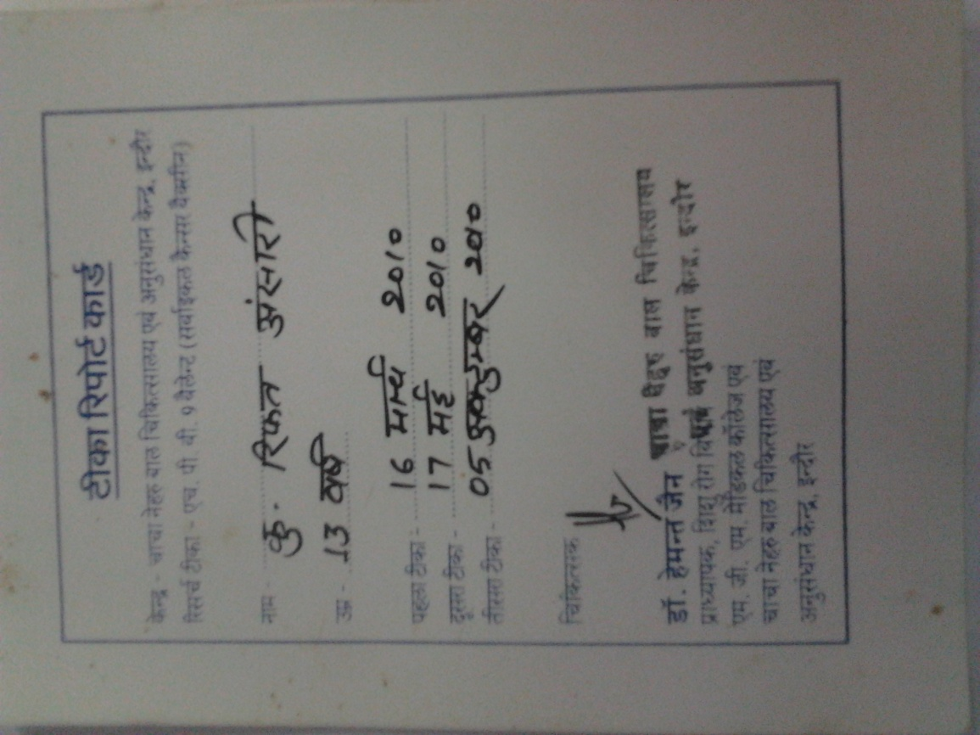

Figure 2: Rifat Ansari
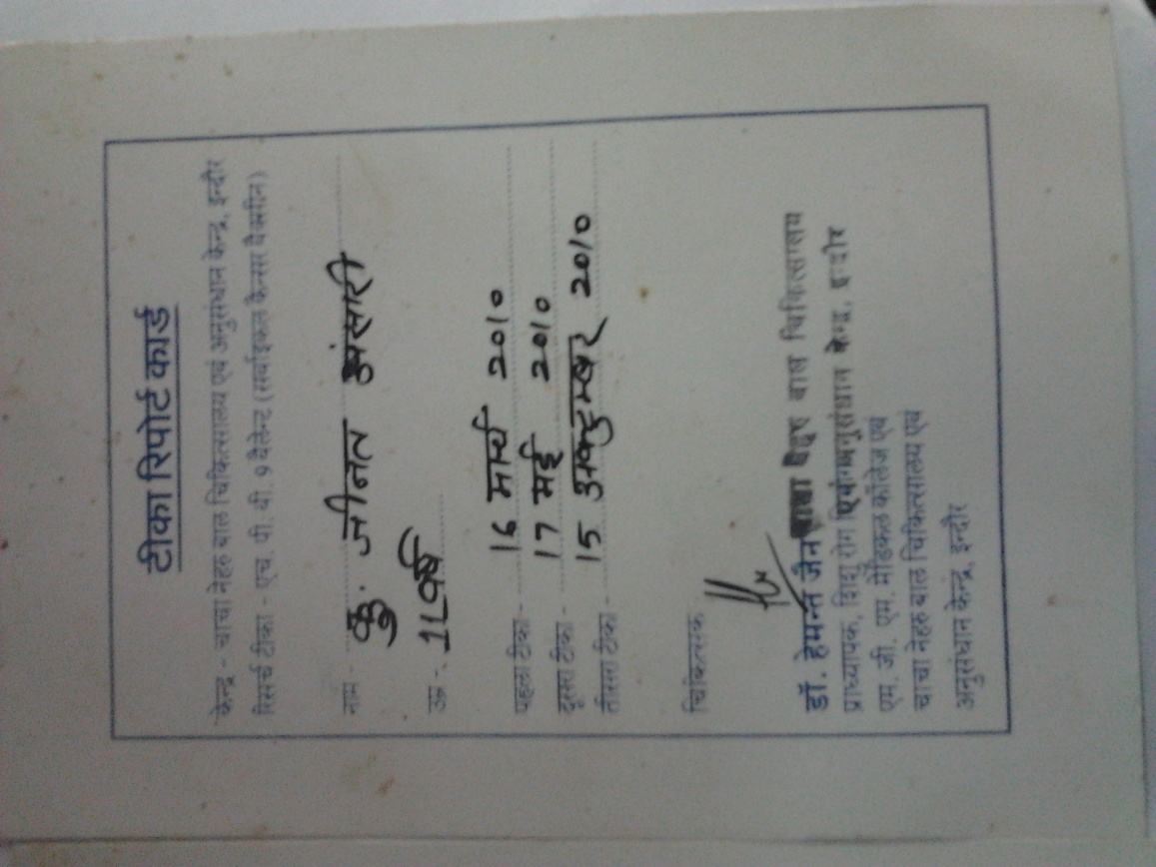
Figure 3: Zeenat Ansari
Follow up: She was not given the doctor’s contact information in case her children experienced side effects from the vaccine. Medical staff took a blood sample from her children every year after the vaccine was given. She has never been given the results of these blood tests, however. Instead, she is simply told the vaccine has been a success.
Post-vaccine medical problems: She did not tell us about any health problems after the vaccine.

Family #3: Shaurya Misra
Family Background
The eldest child is Shaurya (girl, 13 years old), who received the vaccine. She has a little brother and sister who did not receive the vaccine, as they were both underage. Both of the girls in this family still study. Shaurya’s father is a store manager in Greater Kailash Hospital. The father did not specify what his educational level was but he seemed well educated.
Observations
Shaurya lives with her family in a middle class neighbourhood. They have a clean flat on the second floor of a building. It has one bedroom, one kitchen, and one bathroom. The road in front of the house is not paved.
Interview: Shaurya and Shaurya’s father
The team interviewed Shaurya and her father together. Shaurya is currently in the 9th grade. When she got the vaccine she was 9 years old and in the 6th grade. She received all three doses.
Recruitment: Their family doctor, Dr Ashish Dubey, told them about the vaccine. Dr Dubey is Dr Jain’s assistant. They completely trusted the family doctor. The father even said, “Doctor ko bhagwaan mana jata hain” (We consider a doctor to be a god). He said his faith was severely shaken when he discovered they were participating in a clinical trial.
Vaccine description, including benefits and risks: Information was verbally given to Shaurya’s father. He knew the vaccine was for cervical cancer prevention, but Shaurya did not know what cervical cancer was. He was told that this vaccine was an advanced version of the cervical cancer vaccine that combated 12 viruses instead of the 5 viruses that previous vaccines prevented. He was also told that it was being launched in India for the first time and that the vaccine would be given to 44 children in Indore for free. He was comfortable with this fact. He was furthermore told that the vaccine had been used successfully abroad. He thus thought taking this vaccine would be a good idea because it was an advanced version of the previous cervical cancer vaccine, and that if the old version had been approved abroad, the new version would be beneficial.
He did not know, however, that this was a clinical trial. He stated to the team that if they had known the vaccine was not approved abroad, they would not have gotten it. He is not against trials as they can help bring advanced drugs to India, but he feels they should be conducted with proper guidelines and informed consent.
Shaurya and her father were not told anything about potential side effects. The doctor simply told them that all three doses must be taken, otherwise something bad might happen. They were furthermore told that if Shaurya took all three doses, she would not get cancer in the future,
The father had doubts, but he did not ask questions because he trusted the family doctor.
Compensation: Shaurya’s family was given Rs 500 for each vaccine dose. She is called for yearly blood tests as well. The father was suspicious as to why they were being paid, but he did not ask questions because he trusted the doctor.
Consent: The father signed a consent form, as did his daughter.
Shaurya did not feel pressure to take the vaccine. She was with her father and trusted him. The father felt some pressure to sign the consent form, however. There were long lines at the hospital and it was very busy so he could not completely comprehend what was being communicated on the form. He was told he could refuse the vaccine and that participation was voluntary.
Confidentiality: There was no mention of the extent to which Shaurya’s records from the trial would be kept confidential, or who may have access to her records.
Conditions in which vaccine was administered: The vaccine was administered in Chacha Nehru Hospital. The surroundings were clean. The needles were sterile and thrown away after usage in front of the father. Shaurya sat up during the vaccine and was asked to immediately leave afterwards without observation. A technician administered the vaccine instead of the doctor.
Record of vaccination: They had no copy of the consent form, nor a tika parchi.
Follow up: No contact information was given to them after the vaccine. Shaurya goes for yearly blood tests, however the results of those blood tests are never given to her. Her last blood test was in March. Dr. Dubey still calls to check up on her, but he does not impart any information other than it was a success.
Post-vaccine medical problems: They did not report any health problems after the vaccine. Shaurya did not report any period problems either.
The father feels very badly about the doctors behaved with him and how they cheated him. He wants the responsible doctors to be punished, and if possible, terminated. He is ready to testify in court and cooperate with whatever information is required if the need arises. He feels angry that American companies test their vaccines on Indians, yet the benefits from these vaccines go to the American population while the Indians are left to pay the horrific price of being used as guinea pigs. If something had happened to his child he would have been furious. His wife felt badly as well and said whether the vaccine was given to your only child or all your children, a child is a child and the value of life of a child cannot be so easily sacrificed.

Family #4: Shruti Singh
Family Background
Shruti (girl, 17 years old) is a single child who lives with her parents.
Observations
The family lives in a two-story house in a middle class neighborhood and is relatively wealthy. They have a fairly large sitting room and kitchen, and a flat screen TV, and a scooter. Shruti’s father gives her Rs 5 000 per month, and he bought her a car when she joined college.
Interview: Shruti and Shruti’s father
We interviewed Shruti and her father together because they seemed more comfortable that way. The two are quite close and regularly Facebook and text each other. Shruti is in her second year of college studying microbiology. She explained she was “under 16 years” when she got the vaccine. Her father is a graduate, and owns a security company with 700 employees and 6 branches.
Recruitment: Their family doctor, Dr. Ashish Dubey, told them about vaccine. He is an assistant to Dr Jain.
Vaccine description, including benefits and risks: Information about the vaccine was explained to Shruti and her father verbally. They were told the vaccine was to prevent cervical cancer. Shruti understood what cervical cancer is because she is a science student. She was aware that some cervical cancer trials were banned in India. Even though she knew some of these trials were banned, she trusted the doctor and did not ask questions. A detailed description of this vaccine, however, was not given to them. Side effects were not mentioned except for a slight fever after the vaccine. Only benefits were mentioned. They were told Shruti would enjoy 100 percent protection against cervical cancer. They were not told it was a trial.
They consented to the vaccine because they thought it would prevent cancer. Although the father did have questions, he did not initially verbalize these doubts because he trusted his doctor. However, Shruti started to experience some major changes in her personality after the first and second doses which prompted her father to confront the doctor and tell Dr. Dubey of his doubts. It was only at this time that Shruti’s father discovered the vaccine was part of a trial.
Compensation: They were given Rs 250 for the first dose. The father thought it was suspicious that they were being paid and he refused the money. He did not ask questions until after the second injection, however. There was no mention of compensation in case of side effects.
Consent: A consent form was signed by Shruti and her father, but only before the second dose. The father says he did not pressure Shruti to take the vaccine. He did not feel pressured to give it to his child either. They were told they could refuse the vaccine.
Confidentiality: There was no mention of the extent to which Shruti’s records from the trial would be kept confidential, or who may have access to her records.
Conditions in which vaccine was administered: The first dose was administered in Maharaja Yashwantrao (M.Y.) Hospital. The second dose was in Dr Dubey’s private clinic because they felt uncomfortable going to the hospital, perhaps because Shruti felt she was having side effects. Shruti was not asked to wait in the clinic after the vaccine for observation. They were not sure if she was lying down or sitting during the vaccination.
Record of vaccination: No copies of the consent form or tika parchi were given to the family.
Follow up: No one came to check up on Shruti after administration of the vaccine or in between the first and second doses. They did have the doctor’s contact information because it was the family doctor. The doctor said to contact him if side effects occurred, although he said this would be unlikely.
When the father refused to bring Shruti in for the third dose, Dr Dubey never asked why. Instead, the doctor was very persistent on trying to convince them to complete the round of vaccinations.
Post-vaccine medical problems: Within one month of the first dose, Shruti experienced irritableness, anger, and negative thoughts. After the second dose, she seemed depressed, was disorganized, and her grades dropped. She also slit her wrists, and would sleep during the day and stay up all night. Her father took her for counseling. This was all reported to Dr Dubey, however he said they were being misguided and assured them that these effects had nothing to do with the vaccine and were simply normal behaviours of an adolescent.
Family #5: Shruti and Leena Pardesi
Family Background
This family consists of a mother, her daughters Shruti (female, 17 years), and Leena (female, 15 years), and the mother in law. The husband passed away a year and a half ago. The mother is a dhobi, and she alone supports the family. We were only able to interview the mother and Shruti, as Leena had already left for school. No family history of cancer
Observations
The family’s house is in a poor middle class area. . The house is relatively big and clean, with multiple rooms, tiled floors, and an LG double door refrigerator.
Interview: Mother
We interviewed the mother separately from her daughters. We did not know the mother’s age or education level.
Recruitment: A man named Ranjit told them about the vaccine. He called them up and took them to the hospital. He told them not to disclose to anyone the details of the vaccine or Dr Jain’s name.
Ranjit also recruited families #6 and #7 for the trial. The team therefore thinks he was acting as a middleman for Dr Jain to recruit patients for the vaccine trial.
Vaccine description, including benefits and risks: Ranjit verbally described the vaccine to Shruti’s mother. A lady doctor who helped Shruti’s mother fill out her consent form also gave her an information sheet in Hindi. She states she understood everything on the sheet. She was told the vaccine was to prevent cervical cancer but she did not know the name of the vaccine or where it came from. The write up described the history of cervical cancer.
She consented to the vaccine because she was told it was good and that her children would be free from future problems. They also got it because they were told it was over Rs. 10 000 abroad and they were getting it for free.
After the first vaccine dose was given, they were told that they could get a light fever and stomach ache. They were given a thermometer to take home.
They did not know it was a trial at the time of vaccination, and they did not have any questions. The family only discovered it was a trial after all three doses of the vaccine (see “follow up” below).
Compensation: They were given some amount of money for the vaccinations, but we do not know how much.
Consent: The consent form was in English, however there was a lady doctor who explained it to her in Hindi. The doctor told Shruti and her mother that taking the vaccine was not compulsory. The mother did not feel pressure to make her children get the vaccine, and she says she did not pressure her children to take the vaccine either. She gave consent on behalf of her children, and both her children signed a consent form as well.
Confidentiality: There was no mention of the extent to which Shruti and Leena’s records from the trial would be kept confidential, or who may have access to their records.
Conditions in which vaccine was administered: The vaccine was administered at Chacha Nehru hospital. An assistant administered the vaccine while the children were sitting down.
Record of vaccination: The family was given a tika parchi, of which we have pictures.
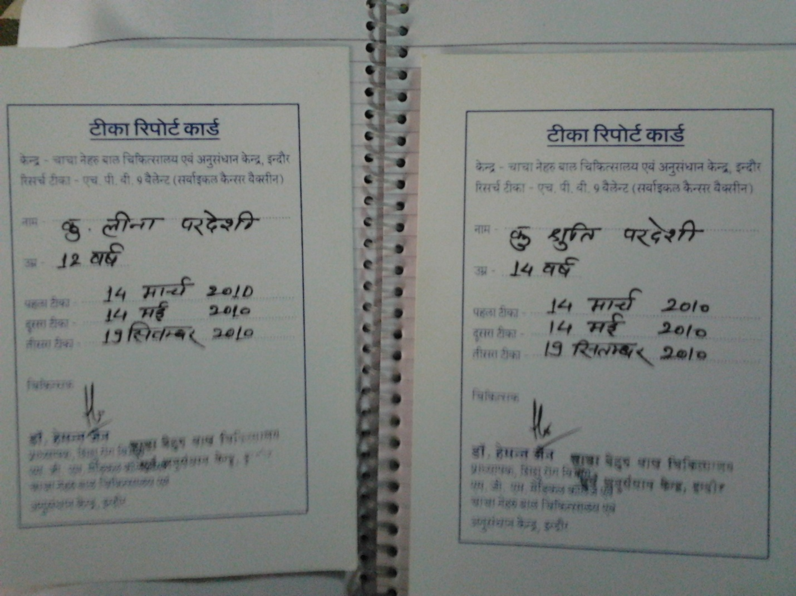
Figure 4: Leena and Shruti Pardesi
Follow up: The family was only called for blood tests during the period of vaccination. There were no other checkups done.
After all three doses of the vaccine were administered, the mother read an article in the newspaper that covered these unethical clinical trials and she was alarmed. The mother in law and the mother took the article and went to meet Dr. Dubey. The family told him about the medical problems the girls were facing and the doctor said that the problems were not related to the injections. Dr. Dubey gave her a prescription for Rubired which is prescribed for anaemia and the family had to purchase this medication themselves. The family had Ranjit’s contact information as well as Dr. Jain’s number. However it is important to note that they obtained Dr. Jain’s number only after they went Dr. Dubey’s office with the newspaper cutting. We have pictures of this. Please see below:

Figure 5: Prescription of Rubired by Dr. Dubey given to Leena Pardesi
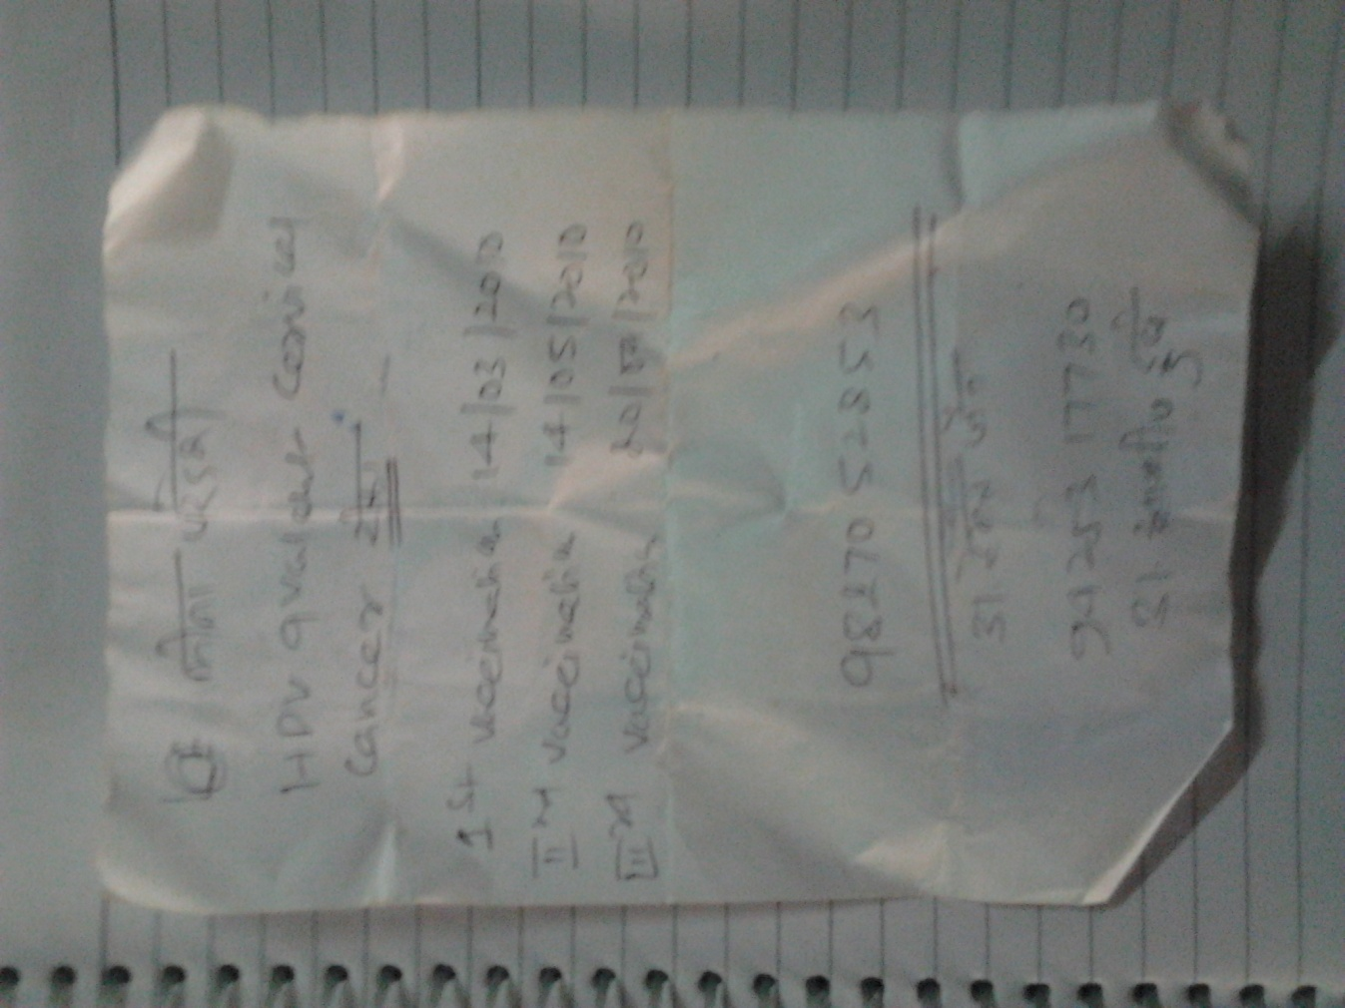
Figure 6: Dr. Jain’s number given to the family by Dr. Dubey
The family contacted Dr Jain for an appointment. When the family arrived at the hospital to meet Dr Jain, however, they were told they were too late and he had already left. It is unclear if the family arrived late for the appointment.
Post-vaccine medical problems: When Shruti went for blood tests, she failed to produce enough blood for a blood test. She also feels dizzy and weak. It is unclear whether this problem was present before or after the vaccination. Leena has a constant pain in her stomach. The family thought this was due to a worm in her stomach, but even after taking medicine for this, the pain has not gone away. Shruti’s periods are late and only after her mother gives her medicine, do her periods come about 8 days later. Leena also has irregular periods.
Interview: Shruti Pardesi
. She is in her first year of college studying economics.
Recruitment: Ranjit told them about the vaccine.
Vaccine description, including benefits and risks: The doctor only explained the vaccine to Shruti’s mother. Her mother was also given a write up in Hindi, but Shruti was not given anything. Shruti was told, however, that the vaccine is to prevent cervical cancer. She has some limited knowledge of cervical cancer. Shruti took the vaccine because it was supposed to prevent cervical cancer. The family was also told that the vaccine had been a success abroad, and that they were being given it free although it is a very expensive vaccine.
Side effects such as fever and stomach ache were only mentioned after the first injection was given to them. They were told if they came down with a fever to use an ice pack to cool themselves down. The family did not know that the vaccine was part of a trial.
Shruti did not have any questions at the time because she trusted her mother.
Compensation: They were given some amount of money for the vaccinations, but we do not know how much.
Consent: Shruti did not feel pressure to take the vaccine. Both Shruti and her mother signed consent forms. The forms were in English, however a doctor explained the content of forms to them in Hindi. They did not pay much attention to it. Shruti signed several forms, one before the first dose and a few more during subsequent doses. It is unclear what these additional forms were for.
Medical history: She was not asked about her medical history. Urine and blood tests were taken immediately before the first dose. Before the second and third dose however, only blood samples were taken and not urine.
Confidentiality: There was no mention of the extent to which Shruti’s records from the trial would be kept confidential, or who may have access to her records.
Conditions in which vaccine was administered: She was sitting up while she got injection. She said the injection was painful. She was asked to leave immediately after the vaccine was given to her, without observation.
Record of vaccination: They were given a record of participating with the dates of the doses. On the tika parchi there was no mention of the name of the vaccine, just to prevent cervical cancer. Shruti took all 3 doses of the vaccine. Please see Figure 4 for Shruti’s tika parchi.
Follow up: No contact information was given. They are called every year for blood tests, however no reports or updates are given to them when they go for these blood tests.
When they went to Dr. Dubey’s office with the article they were only given a prescription for stomach pains. They had to pay for the medicine out of pocket. Please see above for a copy of this prescription given by Dr. Dubey. (Figure 5 and Figure 6).
Post-vaccine medical problems: After the vaccine she has had dizzy spells, problems with being able to produce sufficient amounts of blood for a blood test and possible low blood pressure. She also gets her period late and her mother has to give medicine and only then her period comes 8 days later.

Family #6: Dipesh Hansari
Family Background
The family consists of a mother and her two children: a son, Dipesh, and a daughter. Dipesh’s father recently passed away. Dipesh received the injection when he was 14. He is currently 15 years old and is in the 8th grade. His sister was supposed to receive the vaccine too but they ran out of stock so she did not get it.
Observations
This family lives next door to the Pardesis (family #5). They live in a second story flat in the adjacent building. Their flat was clean, with two or three rooms and tiled floors. The stairs to the flat were dark and very dirty with various items lying around.
Interview: Mother of Dipesh Hansari
The team did not know her education level. She works as a sweeper in the railways and usually gets her medical checkups from the railway hospital.
Recruitment: Ranjit told them about the vaccine.
Vaccine description, including benefits and risks: She was given a form in Hindi describing the history of cervical cancer. It is unclear how much she understood from this form. She thought the vaccine would prevent all illnesses in general, cancer being just one of them. She did not know what cervical cancer is, and she said there was no emphasis on cancer in the explanation that was given to her. She was also told that her child would never fall ill if he got the vaccine. She was furthermore told that the vaccine was very expensive abroad.
She consented to the vaccine for her child because she thought it would be good for him, and she was offered money, so she was tempted. She did not know it was a trial.
The doctor mentioned that side effects like fever could occur. It is unclear if she was told this before or after the vaccination.
She did not ask the doctor any questions.
Compensation: She was offered Rs 200 for the first two doses of the vaccine, and Rs 500 for the last dose.
Consent: She signed a consent form in English, but she did not know what it said. A madam explained the consent form to her in Hindi before the first dose, but she did not understand what she was being told. Her son signed a consent form as well, but the doctors did not explain anything to him beyond telling him that the vaccine would be good for his health.
She knew she could refuse the vaccine. However, the money offered proved be an incentive for her she said, especially since she is single mother and has to raise two children. Furthermore, she stated that she did not pressure her child to take the vaccine.
Confidentiality: There was no mention of the extent to which Dipesh’s records from the trial would be kept confidential, or who may have access to his records.
Conditions in which vaccine was administered: The vaccine was administered at Chacha Nehru Hospital.
Record of vaccination: A tika parchi was given. No records of blood tests were given.
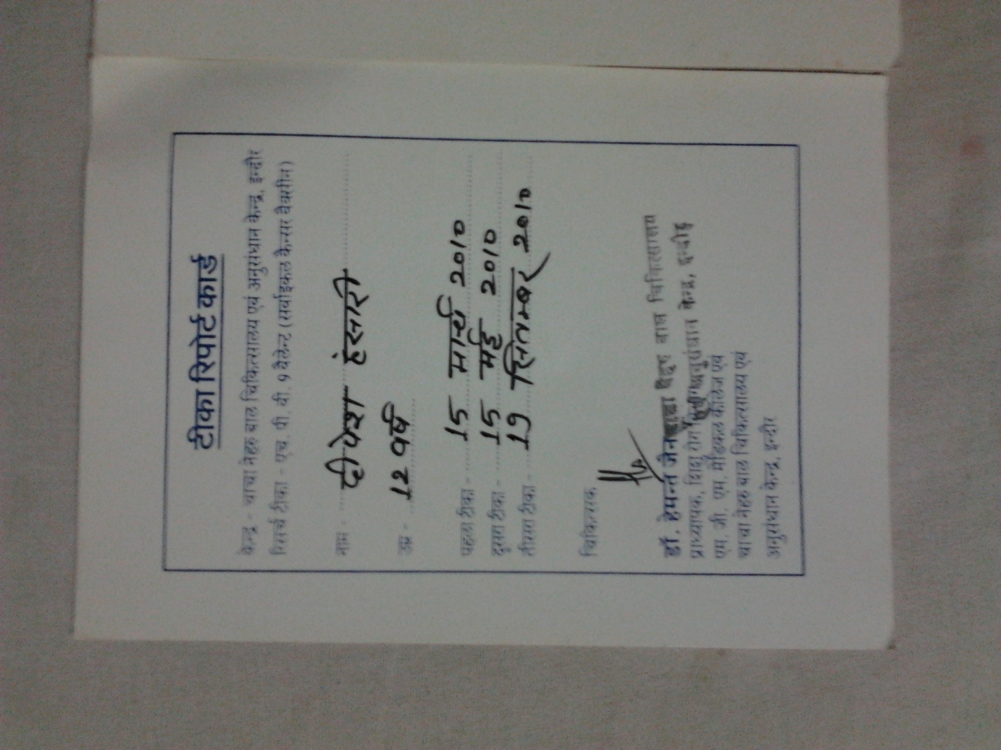
Figure 7: Dipesh Hansari
Follow up: No contact information was given, and she were never told to contact those conducting the trial in case of side effects. When she returned with her son for the second and third doses of the vaccine, however, the doctor did ask about fever and stomach ache. Otherwise, no one has come to check on the child.
They were called for blood tests every year, but they were never told the results of those blood tests.
Post-vaccine medical problems: She did not describe any health problems after the vaccine.

Family #7: Muskan and Akash Hansari
Family Background
This family includes a mother, father, a girl, Muskaan (14 years old) and a boy. They live in between the Pardesi family’s house (family #5) and Dipesh Hansari’s (family #6) home. Both the brother and sister received all three doses of the vaccine. We were only able to interview Muskan and her father.
Observations:
They have one bedroom and a very small attached kitchen on the ground floor of a building. They also have one bed, a TV, and a fan. They are a religious family as demonstrated by their large and clean mandir.
Interview: Father of Muskaan and Mukesh Ansari
The father is a cleaner, and member of the Harijan caste. He studied until the eighth grade.
Recruitment: Ranjit recruited the family.
Vaccine description, including benefits and risks: Ranjit met the family at the hospital and gave the father a write up in Hindi on cervical cancer. While the father apparently read this information, it is unclear how much he understood. Ranjit furthermore told the father that the vaccine would protect his children from illnesses such as typhoid and malaria. The father was not told this vaccine was to prevent cervical cancer. He does not know what cancer, or cervical cancer, is. He does not know what a uterus is. He did not know it was a vaccine trial.
He consented to the vaccine for his children because he was told it would prevent future illness. He was also told that the vaccine abroad was worth Rs 10 000, and the government was giving it for free.
He was told his children could get side effects, including fever and stomach ache. It is unclear whether he was told this information before or after vaccination.
He did not ask questions because it was a government hospital and he trusted the explanation that the doctor gave him. He was told the vaccine was from the government.
Compensation: The family was given Rs 200 for the first and second doses, and Rs. 500 for the last dose. No compensation in case of side effects was mentioned.
Consent: The father was given a consent form in English, and a madam explained the content of the form to him in Hindi. It is unclear what the madam told him exactly, or what the content of the consent form was. He did not feel pressure from anyone to make the child take the vaccine, although he did not know he could refuse the vaccine. He says he did not pressure his children into taking the vaccine either. Both he and his children signed consent forms. They were asked to sign another form after the injection; however it is unclear what this form was for.

Confidentiality: There was no mention of the extent to which Muskaan and Mukesh’s records from the trial would be kept confidential, or who may have access to their records.
Conditions in which vaccine was administered: The vaccine was administered at Chacha Nehru Hospital. The doctor did not tell the children to wait for observation after the vaccination.
Record of vaccination: A tika parchi was given for both children (see below). The family did not receive a copy of the consent form they signed.
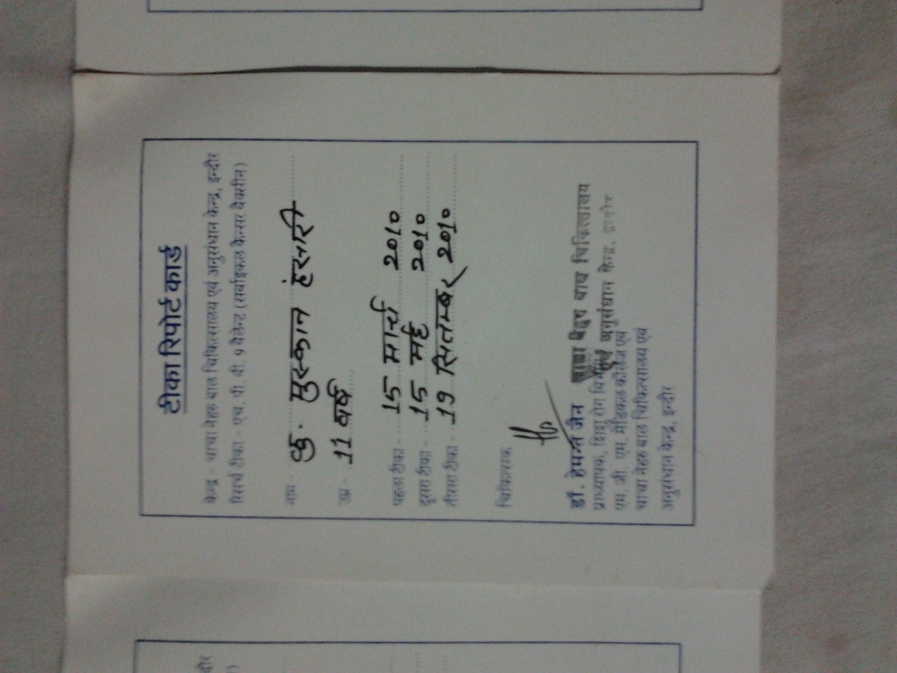
Figure 8: Muskaan Hansari

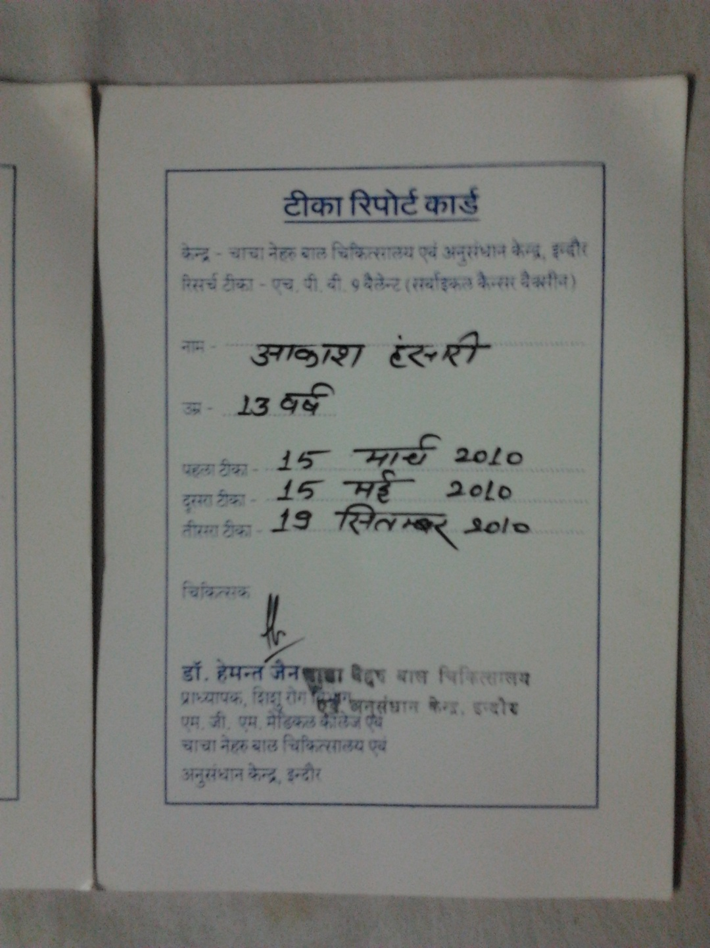
Figure 9: Akash Hansari
Follow up: The doctor told the father to contact them in case of side effects, such as fever or stomach ache. However, the father only has Ranjit’s contact information, not the doctor’s contact information. He was given a thermometer to take home.
Every year Muskan and Mukesh are called for a blood test, and at that point the doctor would ask if they have experienced any difficulties. They are not given the results of these blood tests and are unclear as to what the status of these blood tests is. Other than the blood tests, no one has come to check on the children.
Post-vaccine medical problems: Muskaan felt a bit irritated after the vaccine but overall no side effects were reported after receiving all three doses.
Interview: Muskaan Ansari
Muskaan was 11 or 12 years old at the time of the vaccine. She is now in the 9th grade.
Recruitment: Ranjit told her father about the vaccine. Her father took her to get the vaccine but Muskaan had no idea what the vaccine was for.
Vaccine description, including benefits and risks: The doctor explained the purpose of the vaccine to her father and gave him a write up, but nothing was explained to Muskaan. She therefore did not understand anything about the vaccine. She remembered being told the vaccine was to prevent all kinds of general illnesses. She did not know what cervical cancer is, or where the uterus is located. She did not ask any questions.
Muskaan took the vaccine because her father told her to, and she trusted her father.
Compensation: See the interview for Muskaan’s father above.
Consent: Muskaan did not feel any pressure to take the vaccine, although she also did not know she could refuse it. Muskaan signed a consent form, as did her parents. She signed two or three forms in total, but it is unclear what these forms were for. She did not mention anyone explaining the consent form to her.
Medical history: No medical history was asked of her.
Confidentiality: There was no mention of the extent to which her records from the trial would be kept confidential, or who may have access to her records.
Conditions in which vaccine was administered: The vaccine was administered in Chacha Nehru hospital. She felt no pain during the vaccine. A nurse administered the vaccine while Muskaan sat down. No medicines were given. She was asked to wait after the injection, but she does not remember for how long.
Record of vaccination: She was given a tika parchi. Please see Figure 8.
Follow up: No contact information was given to her or her father other than Ranjit’s. No updates or reports of the blood samples were given to this particular family. No one came to check on Muskaan.
Post-vaccine medical problems: Muskaan did not describe any health problems after the vaccine.
Family #8: Aman Dhawan
Family Background:
This family is composed of a mother, father, and four children: two sons and two daughters. Only one of the sons, Aman (male, exact age unknown), received the vaccine. We were told by his mother that he was 8 years old when he received the first dose and is currently 15 years old... The mother stays at home and rents out her sewing machine to tailors. She has never been to school. The father is a painter, but he is severely handicapped, and is paid Rs 200 per day. Aman was not available when we visited, so we only interviewed his mother.
Observations
The family is very poor and lives in a road side slum. The structure of their house is concrete and sturdy. They have one room which serves the purpose of a bedroom/ meeting area and a small kitchen area that is located in a corner nook of the single room.
Interview: Aman’s Mother
Recruitment: A lady would come to the house every day between 12-1pm when only Aman’s mother was home. The lady would try to persuade her to make only her sons take the vaccine. The mother has seen this lady before in the slum, and it is likely the lady lives in the same area. However, Aman’s mother does not know this lady’s name, phone number, or address. Her sister warned her to not let her child take the vaccine. However, she allowed the lady to take her son because Aman’s mother was under the impression that this vaccine will be beneficial to her son and did not anticipate any negative side effects. Aman’s mother estimates this lady gathered seven or eight boys from the same slum. She also said she saw this lady being paid money by someone.
Vaccine description, including benefits and risks: She did not understand any of the information that was explained to her verbally about the vaccine. She does remember being told the vaccine was to prevent diseases like diphtheria, typhoid, jaundice, and that poor people were being given this vaccine for free. She was also told that the vaccine would be good for her child’s health, and her son would not get any illnesses in the future. There was no mention of cancer. She does not know what cervical cancer is. She does not know what a drug trial is. She did not ask any questions because she didn’t think to question this lady’s intentions.
After the vaccine she was told of possible side effects of the vaccine such as fever and stomach ache...
Compensation: She was given Rs 200 for the first two vaccines, and Rs 500 for the last one. She did not understand why they were giving money for the vaccine. Aman’s mother was told this vaccine was being given to poor children thus she accepted the money without question. The family is also given Rs 500 every time they are called for a blood test, which is once a year.
Consent: She was given a consent form to sign, and a lady verbally explained its contents to her. She could not read anything on the form, however, and it is unclear as to how much she understood from the verbal explanation. It is also uncertain as to what was said in this verbal explanation.
She signed a consent form, and her son signed a consent form as well. She said she did not understand anything, and neither did her son.
While she said at one point in the interview that she felt no pressure to consent to the vaccine, she also told us that she did not have much of a choice. She said that she has four children to raise and the money that they received for each dose provided a large incentive for her to take her child to get this vaccine.
Confidentiality: There was no mention of the extent to which Aman’s records from the trial would be kept confidential, or who may have access to his records.
Conditions in which vaccine was administered: The vaccine was administered at Chacha Nehru Hospital. She was told the vaccine was part of a government run operation. Her son was standing up while he received the vaccine... He was asked to wait for 15 minutes after the injection for observation.
Record of vaccination: The family did not receive copies of the consent forms they signed, nor did they receive a record of the vaccination. Aman’s mother did ask for a record of vaccination, but the doctor refused to give one, saying they knew for sure that everything would be safe and there would be no need to give the mother records or status updates.
Follow up: Aman is called every year for blood tests, and most recently went in March or April of 2013. When Aman goes for these blood tests the doctor asks if everything is okay. No contact information was given to the family, however, in case of side effects. No contact information was given to the Aman’s mother. In fact, she did not even talk to the doctor and does not know the doctor’s name. She has asked for reports and the results of these blood tests but they were not given to her.
Post-vaccine medical problems: Before the injection her son was healthy, but after the injection he lost a lot of weight.

ANALYSIS

Trial continued beyond April 2010:
The V-503 trial continued beyond April 2010 when the health Ministry stopped all trials and these were kept suspended pending government enquiry. The table below drawn on the basis of immunization cards illustrates it
Name of the child I injection 2nd Injection 3rd Injection

Asiya Ansari 17 March 2010 17 May 2010 5th October 2010

Rifat Ansari 16th March 2010 17th May 2010 5th October 2010

Zeenat Ansari 16th March 2010 17th May 2010 15th October 2010

Leena Pardesi 14th March 2010 14th May 2010 19th Sept. 2010

Shruti Pardeshi 14th March 2010 14th May 2010 19th Sept. 2010

Dipesh Hansari 15th March 2010 15th May 2010 19th Sept. 2010

Muskan Hansari 15th March 2010 15th May 2010 19th Sept 2010

Akash Hansari 15th March 2010 15th May 2010 19th Sept 2010

So this is a gross violation by Merck in disregarding government orders in the matter.

Documentary evidence of misleading and incorrect information
The vaccination card names the vaccine as cervical cancer vaccine. It has the seal of Dr Hemant Jain as Associate Professor of the Medical College and also the seal of the Govt. Children’s Hospital – both leading any reader to believe that it is a government sponsored research.
Secondly. Along with saying that it is a 9 valent HPV vaccine the card also says that it is a cervical cancer vaccine. It is thus clear that the trial has gone beyond its mandate and calling an investigational HPV vaccine a cervical cancer vaccine.

Limited to giving injections and taking blood samples

The Indore investigators completely ignored the primary outcome measures other than the geometric mean titers. No recording even of fever or injection site reactions.

Injustices
The recipients of the V503 vaccine came from varying backgrounds yet they all experienced the same injustice of unknowingly participating in a clinical trial.
Recruitment:
Some individuals were recruited by their family doctor or family members, while others were told about the vaccine by middlemen. The use of middlemen is in violation of paragraph 7.19 of the Code of Medical Ethics Regulations 2002, which states: “A Physician shall not use touts or agents for procuring patients.”
Medical history:
No medical history other than age seems to have been recorded for these patients in order to determine their suitability for inclusion in the trial.
Vaccine information and understandability:
In some cases, particularly the poorer families, the participants did not know the vaccine was to prevent cervical cancer. Rather, they were told the vaccine was to prevent general illness like typhoid and diphtheria, with no mention of HPV. For those patients who did have the vaccine described to them, most did not understand what they were being told. Most of them thought it was a government initiative and did not know it was a trial.
Furthermore, the benefits of the vaccine were emphasized over its possible side effects. Side effects, if they were mentioned, were described only as a slight fever and stomach ache. Sometimes the doctors informed patients of possible side effects after the vaccine was administered.
While information on the vaccine and consent was sometimes explained verbally in Hindi, the consent forms were mostly in English, which the families did not understand.
Voluntariness:
The two wealthier, better educated families were informed that they could refuse to take the vaccine, while the poorer families were not informed of this option.
Confidentiality:
Measures regarding confidentiality were not mentioned in any of the interviews the team conducted.
Compensation:
Compensation was paid to all participants interviewed by this fact-finding team. While this is de rigeur in clinical trials, the amount of compensation served as an incentive, particularly for the poorer families, to consent to the vaccine. This violates ICMR Guidelines Chapter III, section II, which states: “… payments should not be so large or the medical services so extensive as to make prospective participants consent readily to enrol in research against their better judgment, which would then be treated as undue inducement…”
Compensation in case of possible side effects was also not mentioned in any of the interviews the team conducted. Families whose children were experiencing side effects from the vaccine were not provided with free medical services.
Contact information and follow up:
A few families had the contact information of their family doctor in case of side effects, but most of the families were given no such contact information. Follow up has been restricted to yearly blood tests most probably to assess the presence of anti-bodies. The families are not told the results of these blood tests.
Record of consent and vaccination:
None of the families interviewed received a copy of the consent form they signed. Most of the families received a tikka parchi (vaccination card) recording the fact that their child received the vaccine, however the tikka parchi does not mention that this was a vaccine trial or HPV.

Alarming medical issues:

In all the team managed to contact the families of 15 children recruited in the trial. Of these four children were continuing to suffer from adverse events of Anaemia, weight loss, mood swings and abdominal pain. In addition, four girls had irregular periods and of them one has bleeding only after her mother gives her medicine.

Seven children developing chronic problems is an alarmingly large number. What is interesting is that the investigator has not taken cognizance of this and hence it is not going too reported in the trial results. Hence data that is not solicited is not going to show up in the safety profile of v-503 defeating the very objective of carrying out the trial. Even in the case of the Anaemic girl only when the family protested a prescription was written out for an iron supplement – without ascertaining the cause of the anaemia or when it developed – considering blood samples were taken from visit 1 onwards every single time that these children visited the hospital it would have been easy to ascertain the history. Such negligence is criminal.

CONCLUSION
Phase III clinical trials are held to gather information on side effects of the vaccine and to assess how a large population responds to it. Vaccines are necessarily given to a healthy population and a proper assessment of adverse events is of great importance. From the continuing blood samples being taken it is clear that the anti-body level or one standard of effectiveness is being monitored for at least three years since the last dose. What is missing is that no information on side effects is being collected by the investigators. No case diaries are being maintained, the children are not being asked about their health problems nor are they being examined leave alone providing treatment for these or compensating the children for any harm suffered by them.

These families have been duped into taking the HPV vaccine and their right to give informed consent was violated. Many of them took the vaccine in good faith and were unsuspectingly used as guinea pigs for yet another clinical trial in India. While there are many provisions on paper regulating the ethical conduct of medical trials, it is clear these standards fall short in reality. Improved implementation of these standards and strict guidelines should be introduced to prevent violations like these occurring again. These data have no scientific value because the health status of children is not known before recruiting them and no data is collected on the adverse events.

A handful of families were told of the side effects before the first dose was administered but a majority of them were told after the first dose was given. The side effects mentioned were stomach ache and fever. Some families were actually given a thermometer to take home after the vaccine. Before the first dose was administered, a blood test was taken and in one case a urine sample was taken as well. No questions about allergies were asked and previous medical history. However one family was asked if their child had had previous illness and another child as asked to fill out a form regarding medical history. We interviewed one child who at the time of blood test, faced shortage of blood. The authorities were not able to extract blood from her veins. She complains of dizziness and low energy. Nothing was done about this until the family went to the clinic with a newspaper article of the dangerous side effects of the HPV vaccine. The doctor prescribed medication but didn’t pay for it. She still complains of dizziness and weakness. Another child experienced weight loss after the vaccine. Another victim experienced mood swings, depression and suicidal tendencies after the vaccine and on account of this refused to take the third dose. She also experienced sleepless nights.
A few families had contact details of the doctor and were told to contact the doctor in case of side effects. In between doses, they were called for yearly blood tests but the reports of these blood tests were not given to them and they were simply told that the vaccine had been a success. Although one of the families had asked for the blood report, the doctor and authorities blatantly refused to hand it over to them.
An important point to note is that not a single family was told they would be compensated by the doctors in case their child suffered any adverse effect as a result of this vaccine. The families were told they were being given this vaccine for free while abroad it was very expensive, more that Rs. 10,000. At the time of the first two doses they were given Rs. 200 which then increased to Rs 500 for the last dose. Some people knew they could refuse, some didn’t but no one refused to take all three doses except for one family. Although the families didn’t feel absolute pressure to take the vaccine, the circumstances the vaccine was administered in made them feel compelled to take it. For example, there were long lines and because of this they couldn’t read the consent form properly and simply signed where they were told. Some others also mentioned that receiving money for this vaccine provided an added incentive because they were poor and had to raise many children. Many of them were given a record of participating and taking this vaccine however the concept of a trial or the actual name of the vaccine was not mentioned. On the sheet they were given, the location and dates of the vaccine were mentioned. Most of them got their vaccine at Chacha Nehru Hospital, one got it at MY hospital. One participant was given the first dose at Chacha Nehru but took the second dose at a private clinic.
A common finding among the families we interviewed was that there was no mention of confidentiality. Families were not told how their contact information would be used let alone if their identity would be kept anonymous. In most of the cases, it was the technician or Doctor’s assistant to administer the vaccine and not the doctor himself. Some children were asked to wait for a few minutes after the vaccine while others were told to immediately leave.

